LOS ANGELES EQUINE ADVISORY COMMITTEE, SB-423 WORKING GROUP
Thursday, September 5, 2024, at 5:30 p.m
Agenda Item #2
Approved at the August 26, 2024 Land Use Committee Meeting. Updated to reflect changes.

REVISED DRAFT for consideration by the Working Group in preparation for Presentation, Discussion, and possible Action(s) by the LA-EAC at their next General Meeting. This section replaces the last two pages of the Agenda Item #2 PDF discussed at the Joint (Trails and Planning and Land Use) Sub-Committee Meeting) 8-26-24.
Preliminary recommendation to the LA-EAC re: SB425

- That the Equine Advisory Committee (EAC) members develop and initiate an advocacy strategy for a 2-year extension of 65913.4 (GC), SB423, the equestrian exemption from high density housing within designated Horse-keeping areas. Safety is the primary issue. Several designated areas are adopted but remain unmapped. The city of Los Angeles will be unable to complete critical mapping prior to July 1, 2025.
- That the EAC approve the development of a new ZI responding to the requirements of SB423 based on the following:
FINDINGS:
  - After extensive research and analysis, the Land Use Comte. and Working Group found the actions and findings of the City Council have already aligned its general plan and zoning with respect to designated Horse-keeping areas and these areas were established more than 5 years ago;1
1 SB423 requirement

  - The designated Horse-keeping areas include “K” Districts, Community Plan Land Use Elements Maps, Specific Plan Land Use Elements Maps, footnotes, and texts; adopted to protect equine areas.
  - Parcels adjoined and only separated by a street or highway from the designated Horse-keeping areas, shall be considered within a Horse-keeping area (“equestrian district”).2 (SB423 requirement because of the safety issues riders face on a street that leads to a trail.)
RECOMMENDATIONS (ZI):
  - The Planning Department to update and publish a revised and readable “City of Los Angeles Equine Keeping Areas” map that reflects horsekeeping areas and buffer zones. The latest version is dated September 2, 2014, and out-of-date (See below).
  - The Planning and Building and Safety Departments review any and all streamlined ministerial project applications in accordance with the new ZI and reject applications for sites not “qualified” within the requirements of SB423.
  - Training and oversight to ensure that all Planning Dep offices and their employees know about and adhere to the ZI procedures for all proposed development projects as currently required.
- That the Open Space, A1, A2, RE40, RE20 and RA Zoned lots also be included in the Revised Map.

- RE: the online document ZI2438 - “Exhibit B” on page 2
FINDINGS:
The Map needs update and visual clarity. When it is enlarged, the outlines of the data are unreadable. It also does not include an overlay from the relevant Community or Specific Plans.
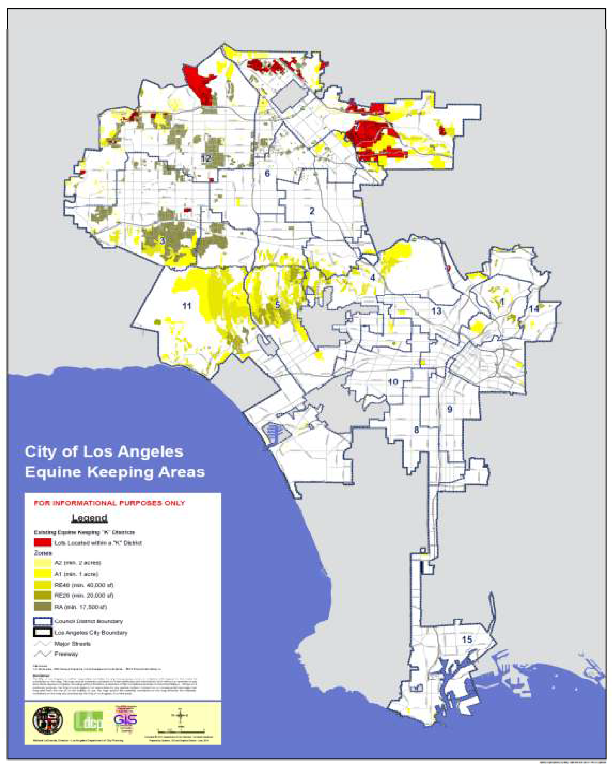
ZI2438, MAP dated September 2, 2014, Needs Update
RECOMMENDATION:
Immediately replace the existing ZI2438 page 2 “Exhibit B” online document be with a clear and readable version.
- Request for data extraction training.
BACKGROUND: This body requested and received data for maps from the Planning Department. However, subsequently was unable to get Planning help or instruction on how to narrow the data to the original requested categories. A second request was made to Planning, but no response was received. How best to arrange data extraction training?

Preliminary recommendation to LA-EAC:

Community Plan Trails Maps be split from the Joint Trails and Planning and Land Use 2024 08 26 Agenda Item #2 Document and transferred to the Trails Subcommittee for review and action.

Please see attachments:
- BOE.Citywide_Equestrian_Trails Update
- ZI2438

